**Car Rental Management System**

Major：B.Tech

Class：CSE 4B

Roll no: 2K19CSUN01069

Submitted By：Anish

Submitted to: Dr. Prinima Gupta (Deptt. Of CSE)

# Index

|  |  |
| --- | --- |
| **S.No** | **Content** |
| 1 | Problem Statement |
| 2 | Use Case Diagram |
| 3 | ER Diagram |
| 4 | DFD(Lv. 0, Lv. 1, Lv. 2) |
| 5 | Flow Chart |
| 6 | Class Diagram |
| 7 | Sequence Diagram |

# Problem Statement

Title : Car Rental Management System

Description : To enhance business processes a software is to be developed for Car Rental Management System. Through the software, customers can view available cars, register, view profile and book car. The system should be user friendly and easy to use.

# Use-Case Diagram

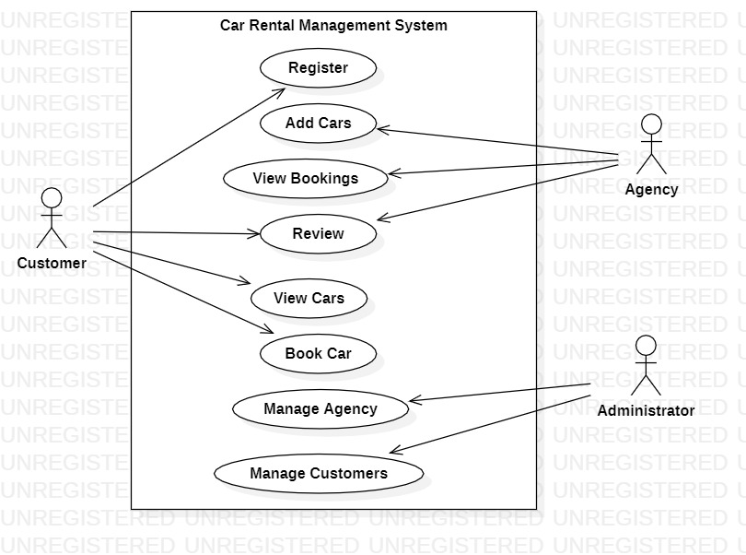

# ER Diagram

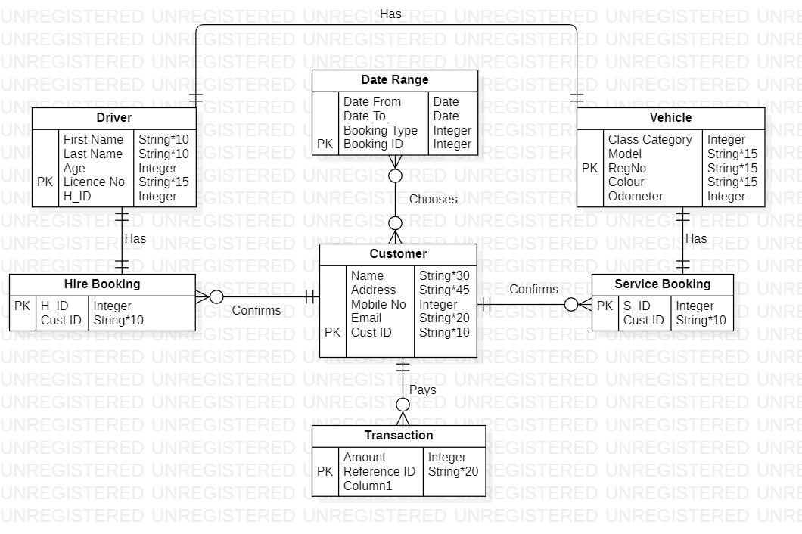

# DFD Level 0

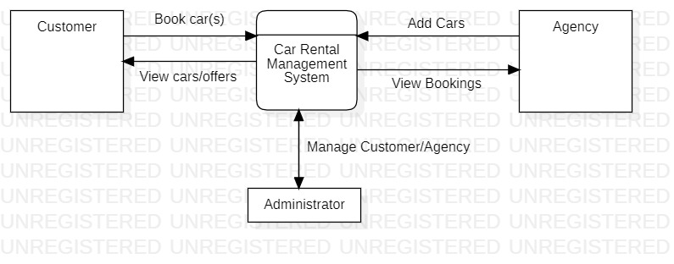

# DFD Level 1

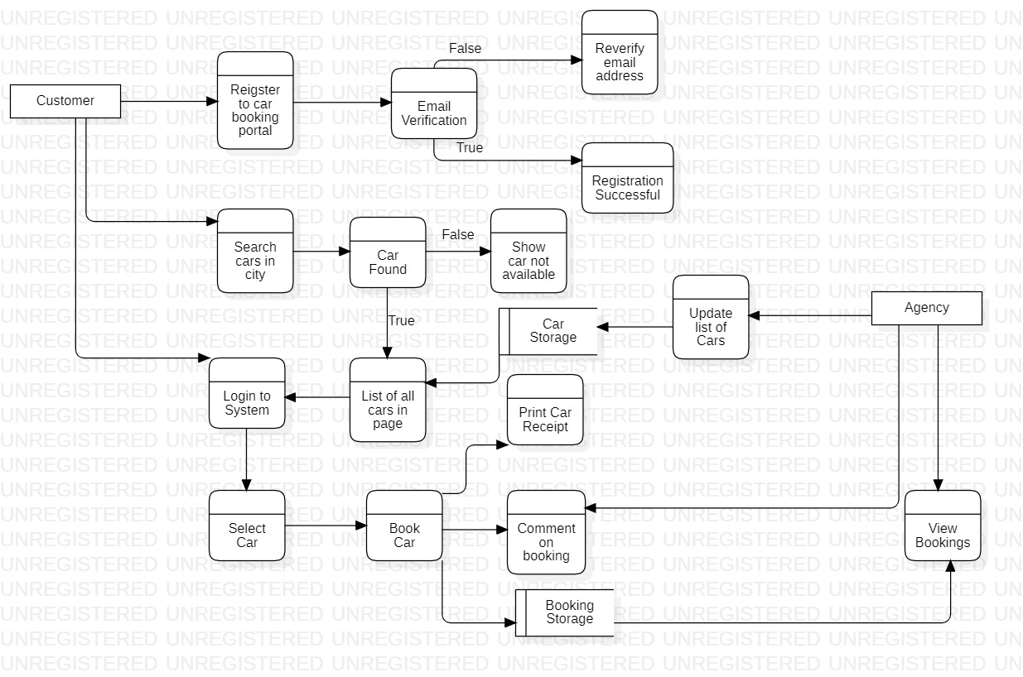

# DFD Level 2

# Flowchart

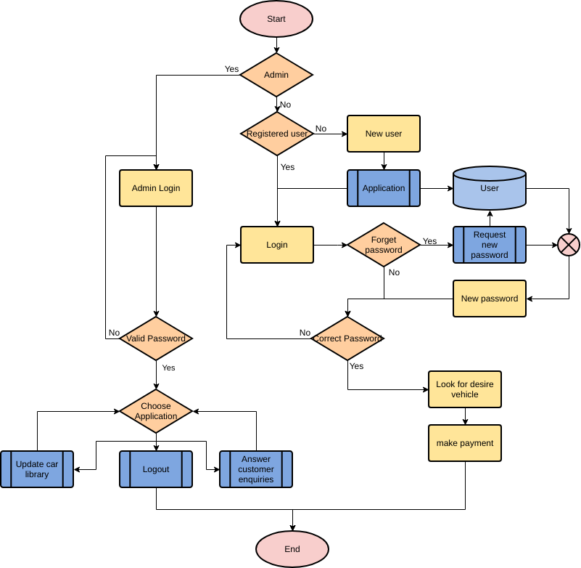

# Class Diagram

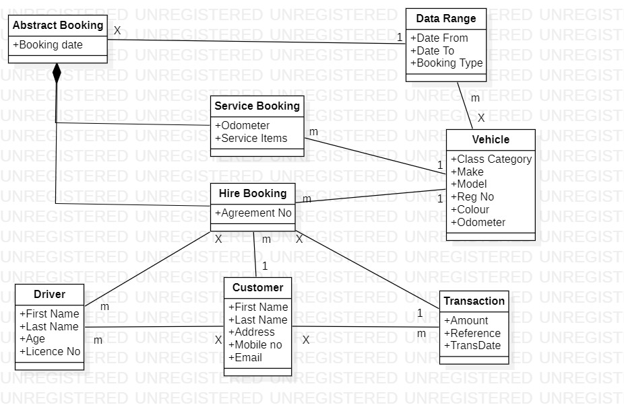

# Sequence Diagram

